


Chemistry (AQA)
Pre-course learning

Introduction:
Following the AQA Specification, we develop your problem solving and analytical skills in the three branches of Chemistry; organic, inorganic and physical. The course requires a high standard of mathematical ability which is applied in a range of contexts from the atom to calculating pH of solutions to determining the structure of an unknown substance. The practical endorsement requires you to complete 12 core practicals across the two years where you will develop your fundamental practical skills.

Tasks:
- Write your own step by step guides for calculating:
  - Empirical Formulae
  - Moles in solid and solution
  - Reacting masses/theoretical yield
- Research and create a timeline showing the changes in our understanding of the structure of the atom from the Ancient Greeks to Niels Bohr.
- Research and write a step by step method for creating a standard solution (any solution with any, named concentration)
- Use your online searching abilities to see if you can find out as much about the topics as you can – minimum 2. Remember if you are a prospective A level chemist, you should aim to push your knowledge.

You can make a 1-page summary for each one you research using Cornell notes and any other sources you find: http://coe.jmu.edu/learningtoolbox/cornellnotes.html

The chemistry of fireworks
What are the component parts of fireworks? What chemical compounds cause fireworks to explode? What chemical compounds are responsible for the colour of fireworks?

Why is copper sulfate blue?
Copper compounds like many of the transition metal compounds have got vivid and distinctive colours – but why?

Aspirin
What was the history of the discovery of aspirin, how do we manufacture aspirin in a modern chemical process?

The hole in the ozone layer
Why did we get a hole in the ozone layer? What chemicals were responsible for it? Why were we producing so many of these chemicals? What is the chemistry behind the ozone destruction?

ITO and the future of touch screen devices
ITO – indium tin oxide is the main component of touch screen in phones and tablets. The element indium is a rare element and we are rapidly running out of it. Chemists are desperately trying to find a more readily available replacement for it. What advances have chemists made in finding a replacement for it?
- Choose three Universities that offer Chemistry or a related subjects as an Undergraduate course, What are the requirements? What skills will you need and develop? Write a summary for each course you find. Which University and course interests you most and why?

Wider Reading: Complete a review of at least three books or journal articles – what did you learn? What was interesting? What questions did it raise for you?

Periodic Tales: The Curious Lives of the Elements (Paperback) Hugh Aldersey-Williams
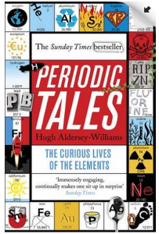
ISBN-10: 0141041455

This book covers the chemical elements, where they come from and how they are used. There are loads of fascinating insights into uses for chemicals you would have never even thought about.

The Science of Everyday Life: Why Teapots Dribble, Toast Burns and Light Bulbs Shine (Hardback) Marty Jopson
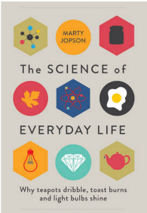
ISBN-10: 1782434186

The title says it all really, lots of interesting stuff about the things around you home!

Bad Science (Paperback) Ben Goldacre
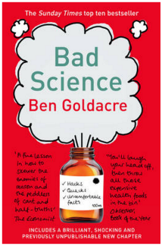
ISBN-10: 000728487X

Here Ben Goldacre takes apart anyone who published bad / misleading or dodgy science – this book will make you think about everything the advertising industry tries to sell you by making it sound ‘sciency’.

Calculations in AS/A Level Chemistry (Paperback) Jim Clark
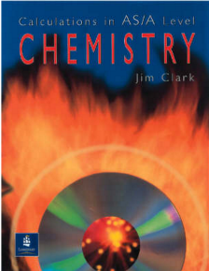
ISBN-10: 0582411270

If you struggle with the calculations side of chemistry, this is the book for you. Covers all the possible calculations you are ever likely to come across. Brought to you by the same guy who wrote the excellent chemguide.co.uk website.

Journals to read/websites to visit

https://royalsociety.org/journals/
https://www.sciencedaily.com/
https://pubs.rsc.org/en/Journals#
https://www.sciencemuseum.org.uk/researchers

Viewing and Listening:

Videos to watch online

Rough science – the Open University – 34 episodes available
Real scientists are ‘stranded’ on an island and are given scientific problems to solve using only what they can find on the island.
Great fun if you like to see how science is used in solving problems.
There are six series in total
https://www.dailymotion.com/playlist/x2igjq#video=xxw6pr

A thread of quicksilver – The Open University
A brilliant history of the most mysterious of elements – mercury. This program shows you how a single substance led to empires and war, as well as showing you come of the cooler properties of mercury.
https://www.youtube.com/watch?v=t46lvTxHHTA

10 weird and wonderful chemical reactions
10 good demonstration reactions, can you work out the chemistry of …. any… of them?
https://www.youtube.com/watch?v=0Bt6RPP2ANI

Chemistry in the Movies
Dantes Peak 1997: Volcano disaster movie.
Use the link to look at the Science of acids and how this links to the movie. http://www.open.edu/openlearn/science-maths-technology/science/chemistry/dantes-peak

Fantastic 4 2005 &2015: Superhero movie
Michio Kaku explains the “real” science behind fantastic four http://nerdist.com/michio-kaku-explains-the-real-science-behind-fantastic-four/

Podcasts/talks

https://www.ted.com/topics/chemistry

https://royalsociety.org/science-events-and-lectures/2019/summer-science-exhibition/summer-science-exhibition-extra/

https://www.chemistryworld.com/podcasts

https://www.rsc.org/periodic-table/podcast

