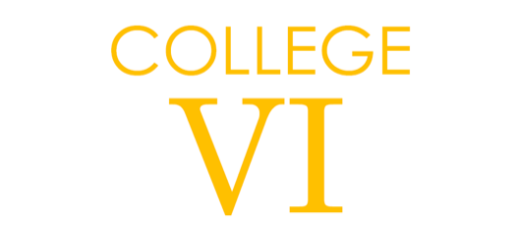


Subject: Mathematics
Pre-course learning

Introduction:

Mathematical skills foster clarity of thought, powers of analysis and evaluation, as well as reasoned judgement and the ability to provide solutions to problems in a structured and logical way. Students will study two main elements: Pure Mathematics and Applied Mathematics. This is a challenging course which requires a high level of commitment from all who study it, regardless of ability.

Mathematics
Pure 1 will be studied in Year 12 and Pure 2 will be studied in Year 13, with elements of both Statistics and Mechanics covered alongside each of these modules. The course is weighted heavily towards Pure, compromising 2/3 of the total course with Mechanics and Statistics worth 1/6 respectively. The core modules cover algebraic processing skills, functions, sequences and series, co-ordinate geometry, trigonometry and calculus. The applied module consists of two main areas of expertise: Mechanics and Statistics. Mechanics considers topics such as forces and dynamics, kinematics, equations of motion and moments. Statistics examines areas such as probability, graphical representation of data, sampling methods and hypothesis testing.
Further Mathematics
We plan on studying A-level Mathematics in Year 12, followed by Further Mathematics in Year 13. The Further Mathematics content consists of two Further Pure modules and two further modules in applied mathematics compromising of Statistics, Mechanics or Decisions. Decision mathematics deals with application of algorithms in order to solve problems. The course is weighted equally between Pure and Applied.

Tasks:
- Please work through the GCSE to GCE transition pack (materials will be available either via email or Google). These are key skills which we expect you to be fluent in at the start of Year 12.
- You will need a Casio Classwiz calculator (or a graphical calculator should you wish to purchase one). If you are able to purchase this before the start of Year 12, please do so and familiarise yourself with its many and various functions (for support please see https://www.drfrostmaths.com/resource.php?rid=262 or the instruction manual!).

Wider Reading:

Underground Maths (www.undergroundmaths.org) has a variety of interesting topics to read and learn about. Below are some ‘bigger picture’ items for reading – however please feel free to explore the website and the activities there!
Thinking about number:
https://undergroundmathematics.org/browse?maxRows=25&startRow=0&typeOption=RichResource&resourceType=12&station=26
Thinking about geometry:
https://undergroundmathematics.org/browse?maxRows=25&startRow=0&typeOption=RichResource&resourceType=12&station=29
Polynomials and rational functions:
https://undergroundmathematics.org/browse?maxRows=25&startRow=0&typeOption=RichResource&resourceType=12&station=18

Nrich (www.nrich.maths.org) has a whole host of problems and puzzles that you can spend some time solving. We recommend that you work through the topics included in the link below – this will help you develop the skills you need to think mathematically.
https://nrich.maths.org/8767

Mathigon (www.mathigon.org) is a ‘textbook’ that is currently under development. It has some puzzles and problems, as well as links to other interesting articles (including a timeline of eminent mathematicians). Please visit the links below and explore:
https://mathigon.org/timeline
https://mathigon.org/applications
https://mathigon.org/eureka

If you fancy a challenge:
https://www.theguardian.com/science/series/alex-bellos-monday-puzzle
Alex Bellos has also written a number of fantastic books – have a look at these if you are able to!

Viewing and Listening:

Ted talks relating to Mathematics:
https://www.ted.com/topics/math

Some quirky videos about a whole host of topics:
https://www.numberphile.com/

