

Subject: Drama and Theatre (Edexcel)
Pre-course learning

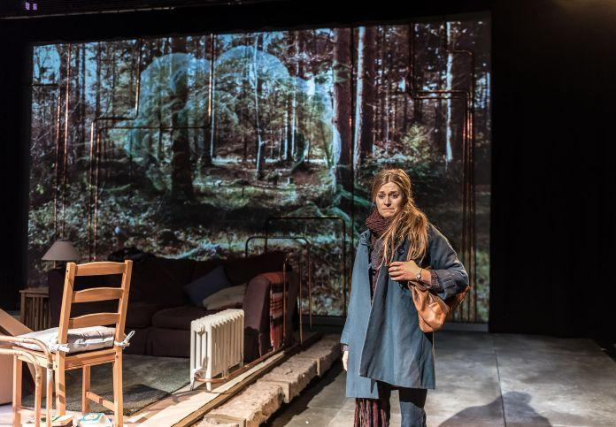

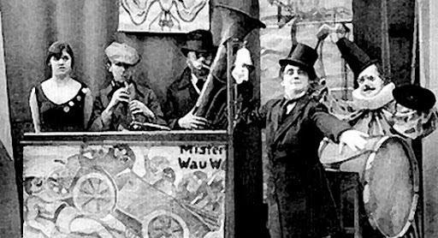

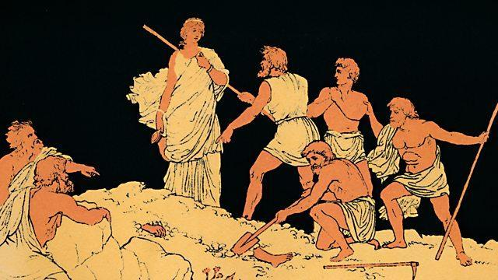

Introduction:
A-Level Drama follows a similar structure to GCSE Drama, in year 12 you complete a devised performance based on an extract from a script. Within your devised piece you need to incorporate a practitioner and use their style in your final piece. You will complete a piece of written coursework about your devised performance analysing the process you went through to get to the end product.
In year 13 you will complete a scripted performance, for your first extract you can choose to either perform in a monologue or duologue and your second extract will be in a group. These extracts are performed to a visiting examiner.
Your written exam is at the end of year 13 and consists of 3 sections. Section A is a live theatre review of a show we will see in the spring term. Section B is on the play ‘Colder than Here’ where you will write from the perspective of an actor and designer based on an unseen extract of the play. Section C is on the play ‘Antigone’, you will design a concept for a production of this play incorporating the practitioner Bertolt Brecht within your design. You will demonstrate how your re-imagined production concept will communicate ideas to a contemporary audience.

Tasks:
1. Research the synopsis for Antigone.
- Create one or more storyboards based on your initial ideas surrounding the plot.
- Create a shoe box set of the play as you imagine it.
- Create character profiles/role on the wall for the characters in the play
2. Areas to research
- Ancient Greek theatre and its importance in society
- The role of religion in Ancient Greek theatre
- Costume and masks in Ancient Greek theatre
- Dionysus and the Dionysia (festival)
- The three tragedians: Sophocles, Aeschylus and Euripides
- Common themes/ glossary of terms used in Greek Tragedy
- Actors in Ancient Greece
- Antigone’s place within the ‘Three Theban Plays’
- The role of the chorus in Greek tragedy
- Contemporary performances of Antigone – first show?
- Use of music in Greek theatre
- Performance spaces (amphitheatres; the skene etc.)
3. Find out the definitions for the key terms:
- Patriarchy
- Didactic
- Morality
- Fate
- Hubris
- Free Will
- Mortality
- Suicide
- Divine Law
- Conscience
- Inaction
- Tyranny
- Pathos/ Logos/ Ethos/ Mythos
- Mimesis
- Hamartia
- Catharsis
- Anagnorisis/ Peripeteia
- Lusis/ Desis

4. Read a synopsis of ‘Colder than Here’
- Create a storyboard for each scene in ‘Colder than Here’
- Complete a role on the wall for each character in ‘Colder than Here’ – Write the facts you know about them on the outside and their emotions on the inside.

5. Research Bertolt Brecht and find out the following:
Who is he? When and where was he born?
What does he believe theatre should be?
What methods would he use in order to achieve his aims in theatre shows? Try to list as many of these as possible!

6. Research Gecko Theatre
Who are they? When did they first start their company? What were the aims?
What is their style of theatre?
What do you think of their style?

Wider Reading:
Read the original version of Antigone online, look at the themes of the play. Read some different versions of Antigone, compare and contrast them to the original.

Read ‘Colder than Here’ by Laura Wade. What is the genre of the play, why do you think she has chosen that genre looking at the topic explored?

Read a play written by Bertolt Brecht (e.g. Mother Courage and Her Children , Life of Galileo, The Caucasian Chalk Circle, The Resistible Rise of Arturo Ui), what do you think his political message was within that play?

Viewing and Listening:
Watch The National Theatre version of Antigone. What have they changed about it? How have they made it appealing to a contemporary audience? How does it highlight the timeless themes?

Watch some examples of scenes from ‘Colder than Here’ online.

Watch ‘The Time of Your Life’ by Gecko Theatre (go to their website). What do you think was the message in the show? What did you think about how they used the set and ensemble?

