

Subject: History (Edexcel)
We follow the Pearson Edexcel A Level. The papers that we study are:
- Paper 1: Russia, 1917–91: from Lenin to Yeltsin (studied in Year 12)
- Paper 2: Mao’s China, 1949–76 (studied in Year 13)
- Paper 3: Lancastrians, Yorkists and Henry VII, 1399-1509 (studied in Year 12)
- Coursework on the Middle East (studied in Year 13)

I have outlined a series of optional tasks below that you can complete to help prepare you for Year 12. The more of these tasks you do, the more prepared you will be!

Task: Choose one book relating to each paper to read over the summer. You do not need to take notes. Some of the books are non-fiction, some are historical fiction – you can choose to read the historical fiction as your book if you like! (For reference, the historical fiction is Fall of Giants by Ken Follett, Azincourt by Bernard Cornwell and The White Queen by Philippa Gregory.
Paper 1: Russia, 1917-91: from Lenin to Yeltsin | Paper 3: Lancastrians, Yorkists and Henry VII, 1399-1509
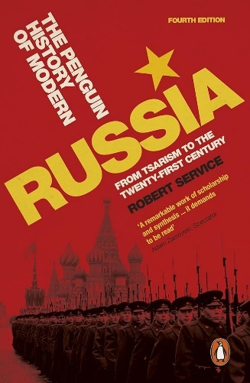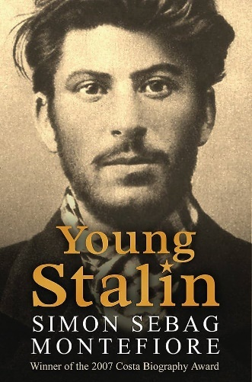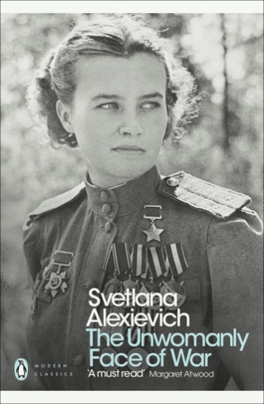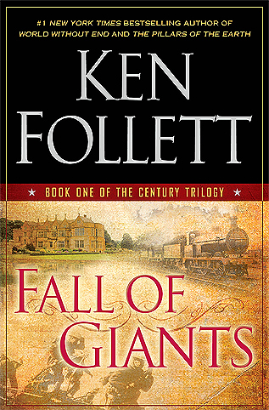 | 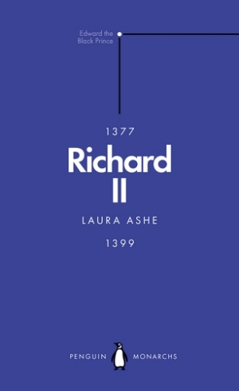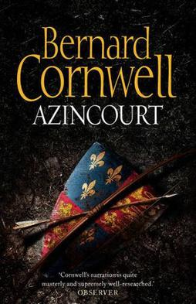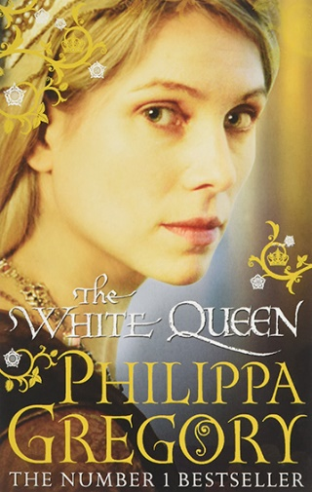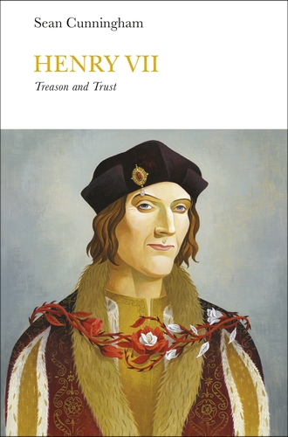

Task: Listen to at least one podcast for each paper. Try taking notes from the podcast.
Paper 1: Russia, 1917-91: from Lenin to Yeltsin
The Emancipation of the Serfs: https://www.bbc.co.uk/programmes/b0b2gspd
Melvyn Bragg and guests discuss Tsar Alexander II's 1861 decree that freed 30 million Russians from serfdom, an act of reform that followed Russia's defeat in the Crimean War.
Tsar Alexander II's assassination: https://www.bbc.co.uk/programmes/p003k9b2
Melvyn Bragg discusses the assassination of Tsar Alexander II in 1881, by a gang of Russian terrorists, which led to start of the revolutionary era in Russia.
The Russo-Japanese War: https://www.bbc.co.uk/programmes/m000tnq3
Melvyn Bragg and guests discuss Japan's unexpected victory over Russia in 1904-5 which gave Japan a new status in the world and pushed Russia into revolution.
Marx: https://www.bbc.co.uk/programmes/p003k9jg
Melvyn Bragg discusses Karl Marx who once said that while other philosophers wanted to interpret the world, he wanted to change it. And he changed the world with his Communist Manifesto.
Lenin: https://www.bbc.co.uk/programmes/p00546pv
Melvyn Bragg investigates what drove the Soviet leader Lenin, and enabled him to develop a model to export communism and build an original political system that remained intact for over seventy years.

Paper 3: Lancastrians, Yorkists and Henry VII, 1399-1509
Hundred Years’ War – Series from The Rest is History podcast – you can listen to this through Apple Podcasts (https://podcasts.apple.com/gb/podcast/hundred-years-war-a-game-of-thrones/id1537788786?i=1000606771435), through Spotify (https://open.spotify.com/show/7Cvsbcjhtur7nplC148TWy - search for episodes 318-321) or through the links below for Youtube.
- https://www.youtube.com/watch?v=I135kDfIRWs
- https://www.youtube.com/watch?v=L90SgiVe2OU
- https://www.youtube.com/watch?v=BBqpJ2P2dX0
- https://www.youtube.com/watch?v=WDeJR9Dn_cQ
The Wars of the Roses: https://www.bbc.co.uk/programmes/p00546sp
Melvyn Bragg discusses the 15th century wars between the royal Houses of Lancaster and York. Do they represent the breakdown of the feudal system or has the political instability been overstated?
The Hanseatic League: https://www.bbc.co.uk/programmes/m001vshs
Melvyn Bragg and guests discuss the Hanseatic League or Hansa which dominated North European and Baltic trade in the medieval period.
Chivalry: https://www.bbc.co.uk/programmes/b03tt7kn
Melvyn Bragg and his guests discuss chivalry, which governed the behaviour of the knights of medieval Europe.
Peasants’ Revolt: https://www.bbc.co.uk/programmes/p0038x8s
Melvyn Bragg and guests discuss the Peasants’ Revolt of 1381 - “When Adam delved and Eve span, who was then the Gentleman?"

