
Year 12 Bridging Work - A Level Religious Studies

Religious Studies is a fantastic subject that helps you build a wide range of skills such as critical thinking, analysis, writing and debating. This Edexcel A Level Religious Studies course comprises 3 different sections:
- Philosophy of Religion
- Ethics
- Study of Christianity

This bridging work will touch on all three papers to give you a brief overview. There is plenty of knowledge that you need at A Level that isn’t covered at GCSE. Hopefully this bridges some of the gaps.
Please complete this work to the best of your ability, as it will not only benefit you but give us an early indication of your performance and potential in this subject. Good first impressions are key! You have 3 main written pieces of work that are due the first lesson in September. There are also optional activities.

Philosophy of Religion
In this section, we want to be able to see that you can think and are open to ideas! We’d like you to write an answer to this question:
“Is God real?”
There are no limits to this question! You can answer it in any way you like. We would advise you spend time researching different philosophers, ideas and that you think about this question from many angles.
Please read this interesting article. Perhaps print it out and highlight points of interest:
https://www.newyorker.com/magazine/2015/02/09/trip-treatment
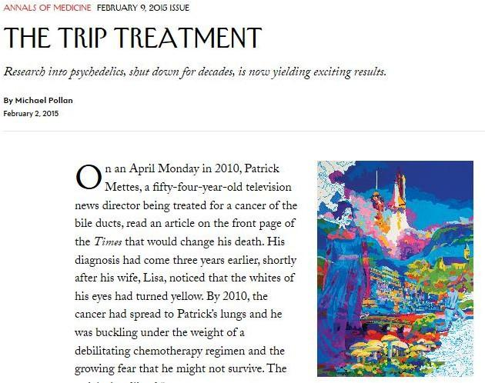
continued: “Is God real?”

Some suggested potential topics to discuss in this essay: Paley’s Design Argument; Aquinas’ Cosmological Argument; The Problem of Evil and Suffering; Miracles; The Bible; The rise of atheism; Religion vs. Science; Personal belief, Religious Experience, Psychology, Biology, Medicine…

2. Ethics Please choose one of the following to research …

  - Value of Human Life Watch: The Good Place – Netflix series: The Trolley Problem! (tram)

Watch: https://www.youtube.com/watch?v=vfIdNV22LQM & https://www.youtube.com/watch?v=lDnO4nDA3kM
Please write your response to these:
    - What is the Trolley problem?
    - What options does Chidi have?
    - What would YOU do if you were in Chidi’s position (above) in the Trolley Problem?

    - Please read p11-28 of the above online book to help you with exploring Utilitarianism.
Make brief notes on: the Hedonic Calculus, Bentham, Mill and P. Singer’s approaches

    - What would a Utilitarian (teleological) approach in this dilemma be?
    - Read Ch2 of the above book: What would Kant’s deontological approach in this dilemma be?
    - Do you think that Chidi is right when he originally said that there is no right answer to the problem?

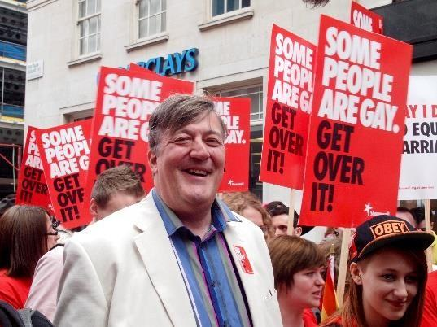
OR

Sexual Ethics:
Please watch this episode of a documentary about: Attitudes Towards Homosexuality https://www.youtube.com/watch?v=IMPl25oraVc
This is the first episode of Stephen Fry’s series ‘Out There’, where he explores attitudes to homosexuality in different parts of the world.
Write your responses trying to support your answers with reasoning:

- Do you think there is a ‘right’ attitude and a ‘wrong’ attitude towards homosexuality? What is it that makes these attitudes right or wrong?

- Some people might argue that different cultures have different ideas about morality, and that these different cultural beliefs should be respected even if we don’t agree with them. Do you think we should always respect the beliefs and attitudes of cultures different from our own, or should we try to persuade them to adopt our own beliefs instead?

- What do you think are the aims of this television series? Do you think they are good aims? Do you think this first episode is successful in achieving its aims?

- What religious reasons do people sometimes give for opposing homosexual relationships? How would you support or oppose these views?

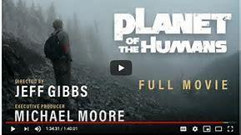
OR

Environmental ethics
    - Make a summary review of the documentary (no more than 2 sides). Please watch this
It is a documentary that dares to say what no one else will this Earth Day — that we are losing the battle to stop climate change on planet earth because we are following leaders who have taken us down the wrong road — selling out the green.
https://www.youtube.com/watch?time_continue=2057&v=Zk11vI-7czE&feature=emb_logo

    - Also summarise some your own current environmental research findings and ideas e.g. Greta Thunberg’s impact on environmental issues.


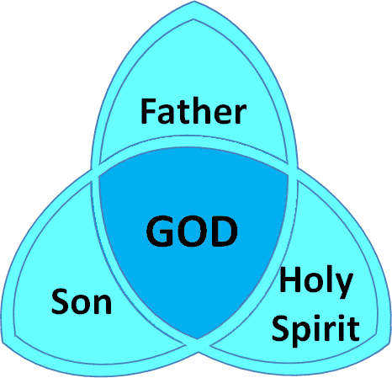
Study of Christianity

This section contains a lot of information and assumes your knowledge of Christianity is good! Therefore, we’d like you to make notes on a few key areas:

- A history of Christianity - Diarmaid MacCulloch's TV series on the history of Christianity: https://www.dailymotion.com/video/x38nlpm
Please watch it, make notes and do some further research if you need to.

- The Bible – watch this YouTube video on the composition of the Bible and make notes – https://www.youtube.com/watch?v=p_TWU5zCXfc

- Jesus – watch ‘The Messiah’ on Netflix

OPTIONAL: Combined Paper Topics Activity:
Watch this documentary, ‘Barra Boy’: https://www.youtube.com/watch?v=nhGX1YCsvAM
Answer the questions below please:
  - What makes evidence convincing or unconvincing?
  - Do you think the story provides convincing evidence for reincarnation? (Philosophy of Religion paper) Why, or why not?

  - What do you think counts as ‘convincing evidence’ for life after death (e.g. scripture, near death experiences, nothing)?
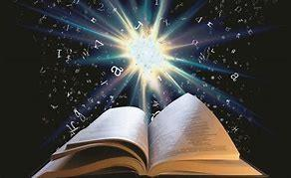
  - Read the accounts in the gospels of the resurrection of Jesus. You could use biblegateway.com if you don’t have a Bible at home. (Christianity paper)

Matthew 28:1 – 10 Mark 16: 1 – 8
Luke 24: 1 – 10 John 20: 1 – 18
  - Do you find these stories convincing? Why, or why not?

  - a) Do you think the stories / accounts contradict each other, or are they just told from different points of view?
b) What might account for the differences and the similarities between the stories / accounts?
Optional Activities: Choose one or two books to make a summary of. Include your own view about the contents. (At least 500 words on each one). All the books below will help with your RS A Level course. Some of the copies below are available reasonably second hand, the cost supplied is from amazon and may vary, others are available in the school library.

Books on Philosophy | Author |  | Cost
The God Delusion | Richard Dawkins |  | £2.14
Teach Yourself Philosophy of Religion | Mel Thompson |  | £2.69
The Philosophy Files | Stephen Law |  | £1.88
Philosophy A Graphic Guide | Dave Johnson and Judy Groves |  | £2.54
50 Philosophy Ideas | Ben Dupre |  | £5.14
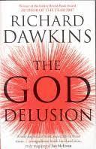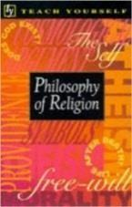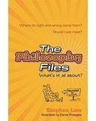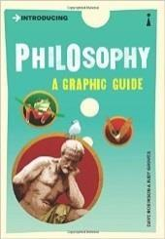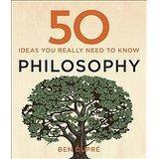
Books on Ethics |  | Author | Cost
Teach Yourself Ethics |  | Mel Thompson | £6.82
A very short introduction to Ethics or Being Good…. |  | Simon Blackburn | £2.81
The Moral Philosophers: An Introduction to Ethics |  | Richard Norman | £4.08
Puzzle of Ethics |  | Peter Vardy | £2.28
Ethical Studies |  | Robert Bowie | £2.81
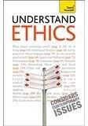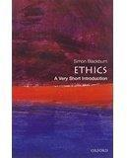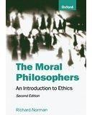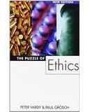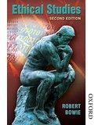

Books on Development in Christianity | Author |  |  | Cost
Christianity – A Very Short Introduction | Linda Woodhead |  |  | £2.81
History of Christianity | Nick Page |  |  | £7.51
Teach Yourself Christianity | John Young |  |  | £2.81
The Story of the Book | Terence Copley |  |  | £2.79
The Shack | William Young |  |  | £1.87
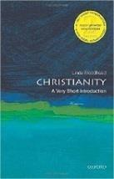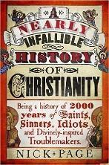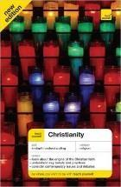 |  | 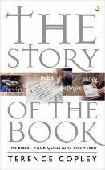 | 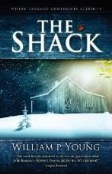

Other RS Media Top Tips:
Podcasts: Also remember the BBC has some great podcasts available: https://www.bbc.co.uk/programmes/p01f0vzr

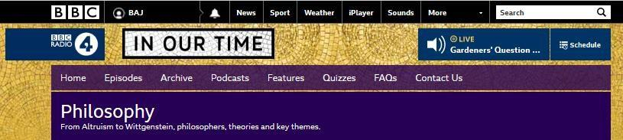

    - BBC - podcasts & programmes - Ethical theories - https://www.bbc.co.uk/programmes/topics/Ethical_theories?fbclid=IwAR1bowymJU mq1stCD343tPB8f4vaoS8S7CO9Si4E0b8CM2yXzL6iuqyBuSU
    - University of Oxford podcasts - Practical ethics - https://podcasts.ox.ac.uk/…/oxforduehiro-centre-practical-

TED TALKS:
Dan Gilbert – why we make bad decisions

Richard Dawkins – militant atheism

Chimamanda Ngozi Adichie – We should all be feminists

Damon Horowitz – Philosophy in prison
https://www.ted.com/talks/kwame_anthony_appiah_is_religion_good_or_bad_this_is _a_trick_question/transcript#t- 22290 Ted Talk by Kwame Anthony Appiah - Is religion good or bad? (This is a trick question)

https://www.ted.com/talks/damon_horowitz/transcript Ted Talk by Damon Horowitz – We Need a Moral Operating System

https://www.ted.com/talks/tom_honey_on_god_and_the_tsunami/transcript Ted Talk by Tom Honey – Why Would God Create A Tsunami?

https://www.youtube.com/watch?v=e8MzPmkNsgU Debate: Atheist vs Christian (Christopher Hitchens vs William Lane Craig)

To Watch:

All kinds of films and series have philosophical and religious ideas in them, so follow your own interests! You could try and use them as a stimulus for thinking and writing, rather than just sitting in front of them:

- The Good Place
- The Matrix
- The Book of Life
- A.I. Artificial Intelligence
- Twelve Angry Men
- Dogma (be careful – a lot of swearing)
- The Story of God with Morgan Freeman (National Geographic – Netflix)
- Richard Dawkins ‘The Root of all Evil’ Part 1: https://vimeo.com/27692770#at=1 Part 2: https://vimeo.com/5928733

Enjoy Exploring!

