Subject: Classics (OCR)
Pre-course learning
Although the empires of Greece and Rome fell hundreds of years ago, their influence and impact has never truly gone away. The worlds of film and literature are filled with examples based on Classical history and mythology. The last ten years alone has given us countless classical films and books indirectly influenced by the ancient world. However, Classics does not just influence the world of entertainment. Many of our modern political concepts come from the ancients: democracy is an Ancient Greek term literally meaning “rule by the people” and the US government went as far as naming one of its ruling bodies after the Roman equivalent: the senate. In the first year, we study Homer’s epic poem, the Odyssey, and ancient Athenian theatre. In the second year, we focus on Virgil’s reply to the Odyssey, the Aeneid, and matters of ancient beliefs and ideas.
We follow the OCR A Level specification. The papers that we study are:
- Paper 1: World of the Hero (Year 12 Homer’s Odyssey/ Year 13 Virgil’s Aeneid)
- Paper 2: Greek Theatre (Year 12)
- Paper 3: Politics of the Late Roman Republic (Year 13)
Below are a series of optional tasks for you to complete to help prepare you for Year 12. The more of these tasks you do, the more prepared you will be!
Task 1 – Classical podcasts
Listen to the suggested podcasts below for some immersion into either the writers we study, or the wider Classical World and take some notes:
Natalie Haynes Stands Up for the Classics
Natalie Haynes takes a fresh look at the ancient world, creating stand-up routines about figures from ancient Greece and Rome. This is some great easy listening about figures central to the work we study. Below are some links to specific episodes which would be most relevant to the pieces of literature we study:
Homer’s Iliad Homer’s Odyssey Euripides Aristophanes Jocasta

In Our Time
Fascinating, in-depth and illuminating discussions about... just about anything which is of interest in human history to the present day. Some of these discussions that are most relevant are linked below:
Homer’s Iliad Homer’s Odyssey Virgil’s Aeneid Greek Comedy Greek Tragedy

Dead to me – The comedy podcast that takes history seriously. Greg Jenner brings together the best names in comedy and history to learn and laugh about the past. Some of these are focused on the ancient world.
Task 2 – Greek Mythology Project
Research one of the Greek Gods below and produce a creative project explaining who they are, why there were worshipped, and the most interesting stories about them and their interactions with mortals:
- Zeus - Hera
- Poseidon - Athena
- Hades - Aphrodite
- Apollo - Artemis
- Hephaestus - Hestia
- Dionysus - Demeter
- Ares - Hermes

Task 3 - Further Reading
Choose one or two books to read over the summer. Some of the books are non-fiction, some are non-fiction, some are historical fiction/some are adaptations of ancient literature.
Greece - Stephen Fry has retold Greek myths in an enjoyable way that provides a useful foundation to the mythology covered across the Classics A Level.
Natalie Haynes retells key myths in a compelling fashion that works well as an introduction.
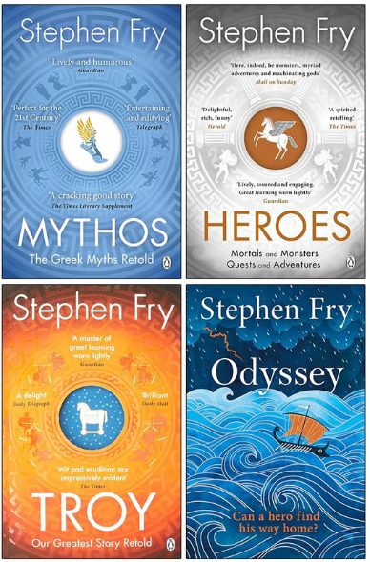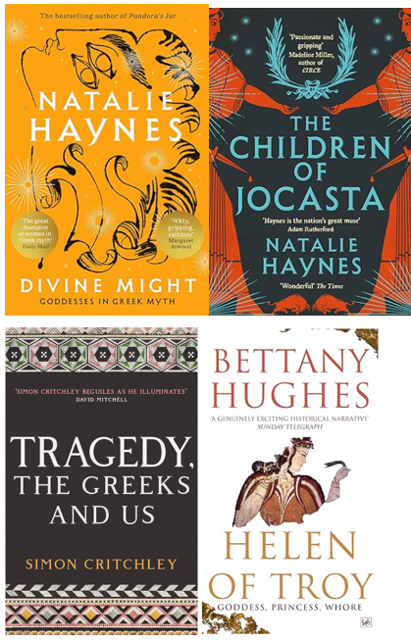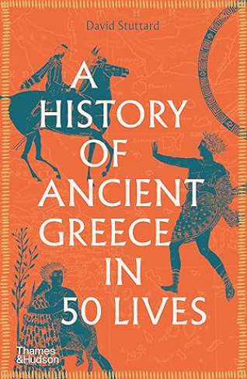

Rome
