Subject: Latin (OCR)
Pre-course learning
Latin is the study of the Ancient Roman world through its language and literature. The course provides a chance for students to extend the skills they developed at GCSE and approach much more evocative and thought-provoking texts. Over the two years of the course, students will study a range of Latin prose authors including Cicero, Tacitus, and Apuleius (students will not have to study all of these authors). They will also study a range of Latin verse authors including Virgil, Lucretius, and Ovid (likewise, students will not have to study all of these authors). In addition to this, they will continue to build up their language skills and vocabulary and along the way they will be able to appreciate how the ancient world influences our own both in terms of culture and language.
We follow the OCR A Level specification. The papers that we study are:
- Paper 1: Unseen Translation
- Paper 2: Comprehension
- Paper 3: Prose Literature (Cicero in Year 12 and Cicero/Tacitus/Apuleius in Year 13)
- Paper 4: Verse Literature (Virgil in Year 12 and Virgil/Ovid/Lucretius in Year 13)
Below are a series of optional tasks for you to complete to help prepare you for Year 12. The more of these tasks you do, the more prepared you will be!
Task 1 – Literature podcasts
Listen to the suggested podcasts below for some immersion into either the writers we study, or the wider Classical World and take some notes:
Natalie Haynes Stands Up for the Classics
Natalie Haynes takes a fresh look at the ancient world, creating stand-up routines about figures from ancient Greece and Rome. This is some great easy listening about figures central to the work we study. Below are some links to specific episodes which would be most relevant to the pieces of literature we study:
Cicero Homer’s Iliad Homer’s Odyssey Aphrodite

In Our Time
Fascinating, in-depth and illuminating discussions about... just about anything which is of interest in human history to the present day. Some of these discussions that are most relevant are linked below:
Cicero Virgil’s Aeneid Virgil’s Ecologues Homer’s Iliad

Task 2 - Vocabulary/Grammar
Maintain mastery of GCSE vocabulary found here.
A vocabulary/grammar tester for this purpose can be found here.

Task 3 - Translation
Translate the passage below as some practice to see what you can remember! You can use the vocabulary list from the link in Task 1.
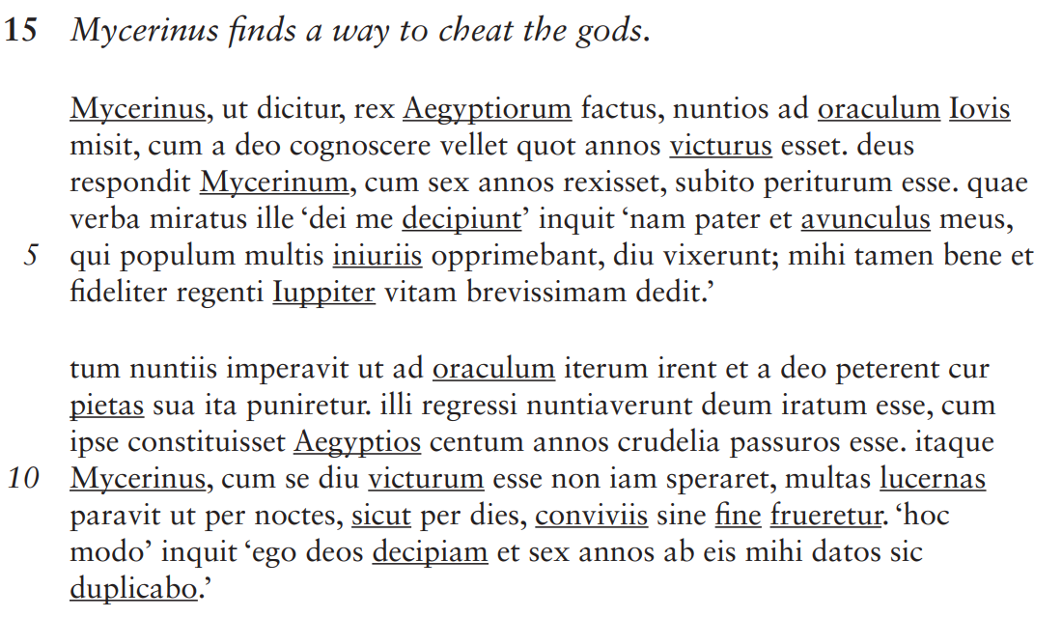
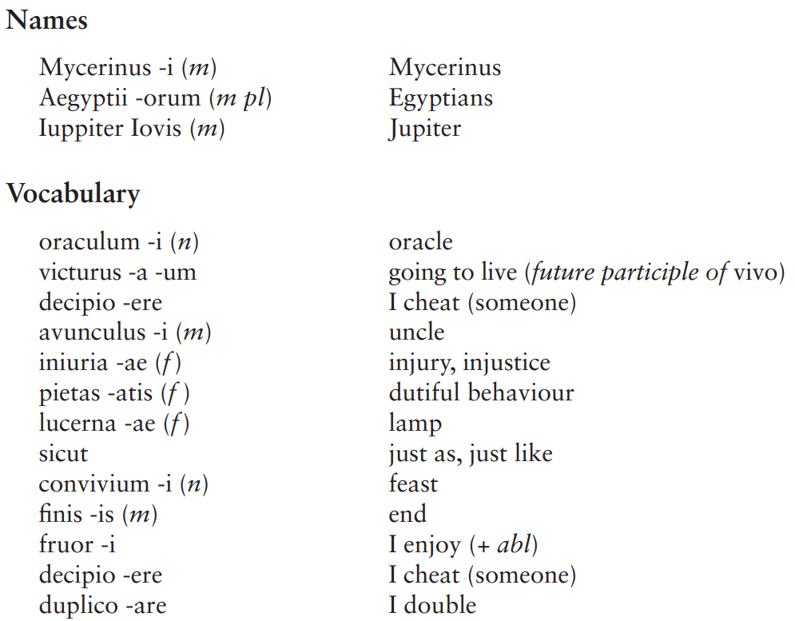

Task 4 - Further Reading
Choose one book relating to each paper to read over the summer. Some of the books are non-fiction, some are non-fiction, some are historical fiction/some are adaptations of ancient literature. For Cicero - Robert Harris and Colleen McCullough are historical fiction, Kay Bujak, Tempest and Holland are histories. For Virgil, Bartsch has translated his Aeneid fairly recently, the other three works are retellings of myths related to Aeneas. You are encouraged to read more widely about the Classical World too!
Year 12 – Prose Literature - Cicero | Year 12 – Verse Literature – Virgil
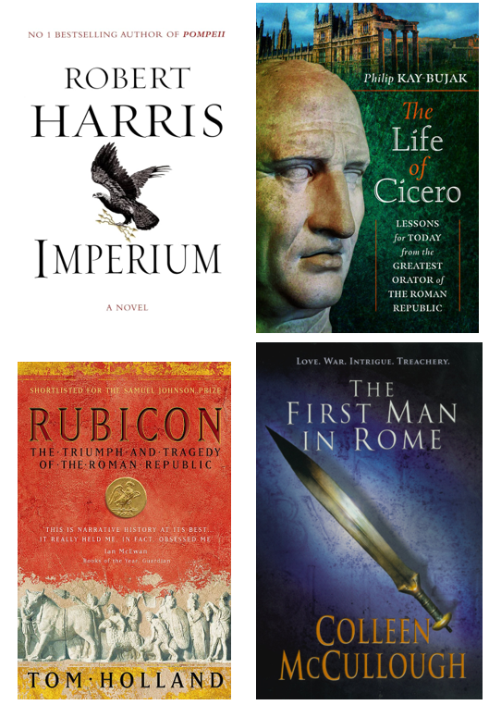 | 