

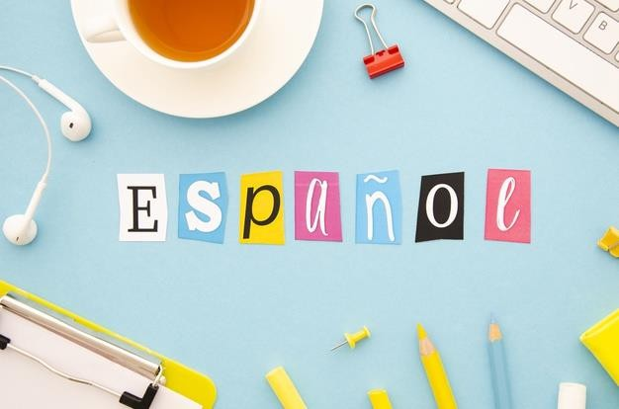

Preparing for A-level Spanish



Content page
Bienvenidos a la case de español 2
Welcome to your preparation 3
Read 4
Newspapers and Magazines 4
Websites 4
Websites for research 5
On-line dictionary 5
Sign up to Twitter 6
Watch 7
TV 7
Movies 7
Listen 8
Radio 8
Music 8
Grammar Practice 9
What should I know by now? 9
Links to Grammar Practice Exercises 9
Tasks 10
Task Log 11
A Level Course Overview. 12/13
Handy vocab 14

¡Bienvenidos a la clase de español!

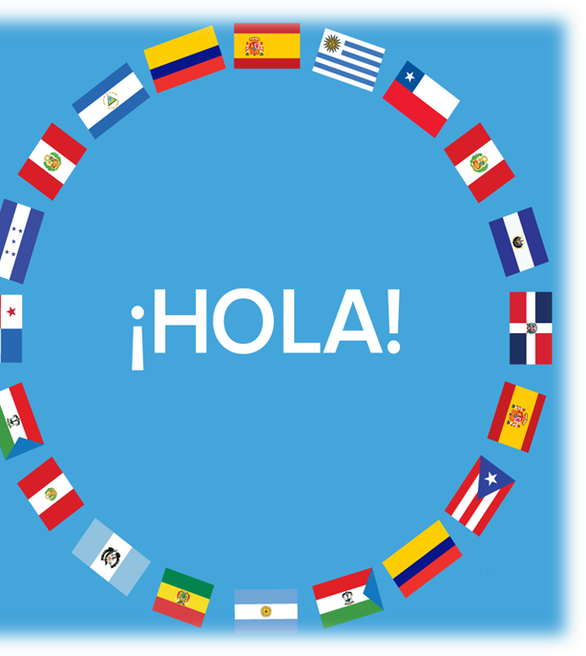
Congratulations on choosing to study Spanish at Riddlesdown Collegiate. At A-level, students greatly develop their awareness of the culture, society and recent history of Spain and Spanish-speaking countries.
Throughout the two years, all students are actively encouraged to develop their listening and reading skills through the use of media, including interactive web resources. Literature and film studies as well as independent research are also important features of the course.

How to prepare for Spanish at A Level



The best way to prepare yourself is to ensure that you have a firm grasp of the language and skills which you have already used at GCSE.
Thorough revision of these over the summer will make you more confident when you start the course in September and prepare you for a more independent approach to learning.

Welcome to your preparation for AL SPANISH!

The activities below are all designed to be fun, accessible and to keep you actively learning about topics you are interested in. Whilst you will not be formally assessed on the completion of these, you will find them hugely beneficial during your time at College.

  Complete this MOOC. This free online course explores your creativity as well as your ability to follow instructions in Spanish  ¡El artista está en casa!  Udemy | Listen to this podcast and learn    about the letter ñ, unique to the Spanish alphabet: its origins, how to type it and much more. You can download the PDF transcript or access it here!  La letra ñ  Unlimited Spanish- Habla Español | Read this article about    common mistakes in Spanish. Be ahead of the game by raising your awareness of these traps. You will have plenty of opportunities in A Level to test this knowledge.  Errores comunes  Spanish Dict | Watch this TED talk about why    and how music raises our emotions. You can follow this by downloading the app Lyrics and learn Spanish through songs.  ¿Por qué nos emociona la música?  TED Talk – Paolo Bortolameolli | Complete this interactive lesson on inland Spain, an aspect less known by tourists. This includes activities at different levels and gives you an insight on things we study at A Level.  La España interior  ProfeDeELE.es
Listen to this video  that explores the wall in the Spanish city of Melilla, designed to stop illegal immigration between the European Union and Africa. Learn about this controversial topic which we will be studying in detail in class. La Valla de Melilla Youtube - BBC Mundo | Read this article about  Donovan Carrillo. In this interview to an exceptional ice skater you will find inspiration, as well as an opportunity to check your understanding of tenses. Entrevista con…Donovan Carillo  Muy Interesante Junior | Watch this video and learn about  surprising habits in the Spanish culture, such as organ donation or why we hang pig legs in  bars…all useful to know for A Level!  20 Curiosidades de España  Youtube – Supercurioso |   Complete this course on  understanding and using natural language. You will learn to express yourself better, improve your audio skills and learn culture through a series of video activities  Understanding spoken Spanish  Open University | Listen to this podcast  about Spanish inventors: from mops to cable cars! The podcast is followed by a small quiz.  Inventos españoles  ProfeDeELE.es
Read this article about civilizations    prior to the arrival of Christopher Columbus to the Americas. Place the countries in a map. We will be extending this knowledge in class.  Culturas precolombinas  Hablacultura.com | Watch this video about  expressions in Spanish related to food. They are so quirky. There are many more funny videos like this here.  Expresiones en español de comida  Youtube – Hoy hablamos | Complete this MOOC    on the most controversial region of Spain: Catalonia. Learn about its language, history, culture and why it is up in arms.  Getting to Know Catalonia Future Learn | Listen to this podcast  about the Spanish monarchy. Learn why a female heiress to the throne is an issue and compare it to the British monarchy.  La Familial Real  Notes in Spanish | Watch this TED talk on  “writing” the story of your life! This is a humorous reflection and philosophical insight.  Great for literature and language lovers too!  Reescribe el cuento de tu vida  TED Talks – Lucas Raspall

Read …
Keep your own vocabulary book for new expressions you come across – there is a sheet at the back of this booklet to start you off. You could order it alphabetically, by topic area based on what we are going to study or just use it as a diary and scribble away your Spanish development in it.
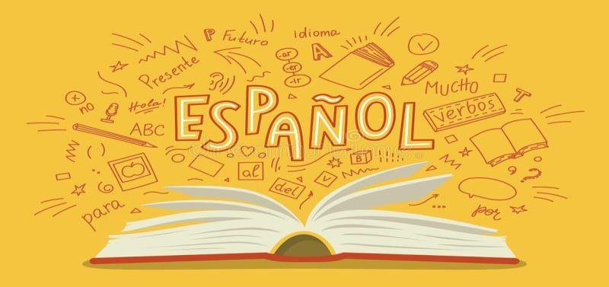


Newspapers and Magazines

Read a foreign language newspaper – El Mundo in Spanish is available in larger paper shops. El Mundo has its own website http://www.elmundo.es/ so that you can read the paper online. You do not have to read the paper cover to cover, just scan the headlines and pick out ONE article that grabs your attention.

- This website gives you access to newspapers all over the world. Here is the link to a range of Spanish papers. http://www.mediatico.com/en/newspapers/europ/spain/national/

- This website is a more light hearted newspaper which covers global stories as well as gossip. http://www.20minutos.es/ Also try http://www.20minutos.tv/ This is the TV Channel for this newspaper:
- The website http://www.diariosur.es/ is from a newspaper in the south of Spain. In addition to articles, it contains a number of clips from news stories and links through to sports etc. It also has links through to specific parts of Spain, which may be useful when you start a project on a particular region of Spain.

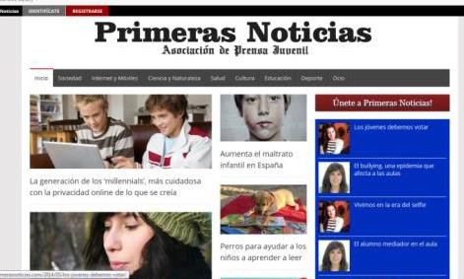
In Spain there is also a news website for young people: http://primerasnoticias.com/ It has sections on the Internet and Mobile Technology; Science and Wildlife; Education; Culture; Sport; Society and Health. A glance today contained articles about Facebook, video games and bullying to name but a few.

Websites

Switch to Spanish browsers such as http://www.terra.es/ and http://es.yahoo.com/ or www.yahoo.es as well as www.google.es . This way, you will read Spanish every time you log on and it will become part of your everyday activity.

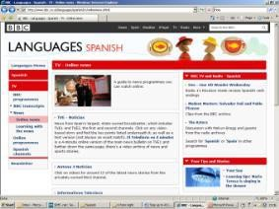
Look at the BBC website http://www.bbc.co.uk/languages/spanish/tv/onlinenews.shtml for links to Spanish programmes available on line. And http://www.bbc.co.uk/mundo/ takes you through to news in Spanish.

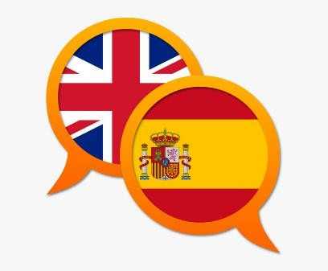
Websites for research
Once you actually start A-Level in September, you will learn all about the history and culture of Spanish speakers. Here are some websites bursting with information about Spain. Always start your research with these websites as it is easy to get bogged down when looking for help on the internet.

If you are searching for information, try switching to the Spanish www.es.wikipedia. Remember that anyone can write on Wikipedia so you must validate your research elsewhere and never quote from it! It is a good place to start though.

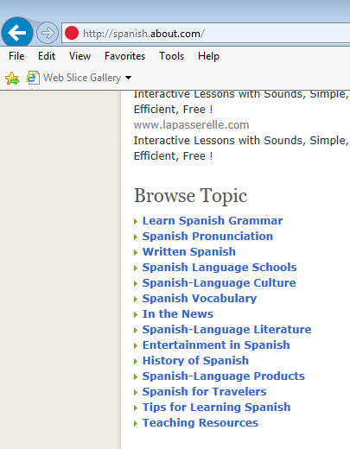
A Spanish government run website: www.mec.es (Consejería de Educación)
A website in English with some great links to various topics: http://spanish.about.com/

British Council support available from http://schoolsonline.britishcouncil.org/ Keep your eyes peeled as they often have trips to Spain for free! You have to apply for them but they are an amazing opportunity to build your Spanish skills. There is no better way to learn a language than by spending time in that country.

The National Centre for Languages http://www.cilt.org.uk/home.aspx for information on how to set up blogs and also further links to grants for trips to Spain etc.

On-line dictionary

A good on-line dictionary is: http://www.wordreference.com/
TOP TIP: Don’t look up every word you are not sure of when reading an article/ book.
When you are reading articles etc., try not to look up every word as it will take you forever. Skim and scan the text to get the gist. Remember to use the context or the article, cognates and common sense to figure out what the article is saying. Pick out a couple of words that you like the look of, that you feel may be real hurdles to getting the idea of the text, look them up carefully and add them to your vocab booklet. The aim at this stage is to get the gist of the article, not be able to translate it completely. Translation is a whole different ball game and you will learn it soon enough.
You will be surprised how much more enjoyable reading will be if you really pay attention to this tip.

Sign up to Twitter
Sign up to Twitter for authentic text that you can quickly flick through. They will help you pick up the language even when lazily browsing twitter. Some ideas are:

@Spain - The official Twitter for tourism in Spain.

@LaFraseDelDia_ - Más que palabras. A Spanish site which tweets inspirational sayings for each day.

@spanishlanguage – Official Twitter account for Transparent Language Spanish. Learn the language with free resources, social media, and research-based software that works. Tweets expressions, phrases, words and articles in Spanish.
@spanishaddicts – El español de la calle (typical spoken Spanish). Esto no son simples traducciones literales, es mucho más que eso. Spanish phrases, vocab, articles and more.

@spanishxxx2 – Free Spanish Sentences Vocabulary Pronunciation Grammar Tests. Tweets vocab, articles, and quizzes.

@muyinteresante – Revista de ciencia, historia, tecnología, salud, psicología, innovación y curiosidades. A Spanish news organisation that tweets in Spanish only. Great for practicing your reading skills

TOP TIP: Sign up to Twitter and register to a feed that tweets a word or so a day
A word a day is a fantastic way of building your vocabulary. Here are some to choose from:
@SpanishDict - Learn Spanish on the web. Tweets a random Spanish word frequently with the translation.

@VamosSpanish– A word a day goes a long way! Use this online resource to enhance your Spanish learning and ask questions. Tweets words and phrases and translates them. Also tweets other facts and grammar.
@EduLearnSpanish – Learn 3 new words a day on Twitter!

@SpanishWords4U – Spanish Word A Day and computer programs to learn Spanish. Tweets a new Spanish word everyday with example sentences.

@LL_Spanish – Learn Spanish with words & phrases of the day from Living Language! Tweets Spanish phrases, words, articles and more.

Watch…


Television
Watch the latest news in Spanish http://www.rtve.es/, or even just the weather forecast http://www.rtve.es/eltiempo/. Take in some culinary delights with Spanish Master Chef http://www.rtve.es/television/masterchef/ or some football http://www.rtve.es/deportes/champions-league/

You can also access the TV using:
- Your own TV. If you get Euronews, you can put it into Spanish by pressing the red button
- Look at http://broadcast-live.com/television/spanish.html. This website gives you access to the TV stations that are streaming TV including http://www.canalsur.es/portada-2808.html
- Another TV station is http://www.antena3.com/. This gives you access to loads of soaps and dramas etc
- BBC Website http://www.bbc.co.uk/education/subjects/z4dqxnb . If you have trouble bringing the website up, type in www.bbc.co.uk/education. Then select England GCSE and scroll down until you find Modern Foreign Languages. Behind both the Speaking and Listening tabs there are loads of great videos to watch that only last a few minutes and they are a great way to practice your listening skills.


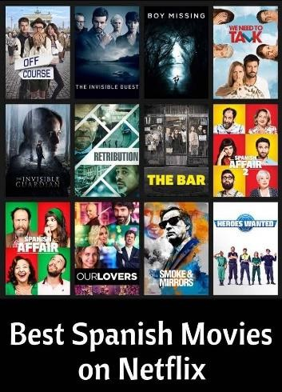
Movies
Watch Spanish films and TV shows on Netflix.
Money Heist, Cable Girls, Elite, The Ministry of Time… Ideally in Spanish with English subtitles.

Listen to the radio…
The great thing about listening to the radio is that you can get on with something else at the same time.
Listen live using the Eschuchar ahora or the En directo button. It sometimes takes a while to buffer so be patient.

- Radio Nacional de España (RNE) (www.rtve.es )
- Radio 1(Radio Nacional) es la radio generalista
de RNE. Sus programas llegan a todos los públicos. Noticias, entretenimiento, cultura, deportes...
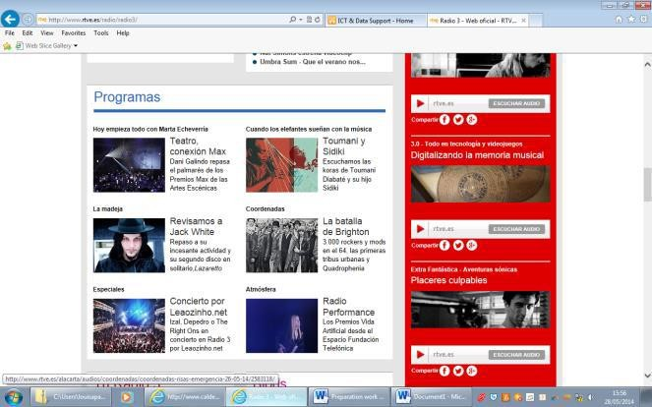
- Radio 5 es la radio dedicada al mundo de la actualidad, con noticias durante las 24 horas del día, todos los días del año. http://www.rtve.es/radio/radio5/
TOP TIP: Listen to Radio 3
Radio 3 is the radio station that the young listen to. It is set up just like Radio 1 or Capital FM and so has music videos and interviews to watch too. Also, if you like 80s music, try M80 Radio http://www.m80radio.com/ .
- Radio 3 es la radio más joven, la preocupada por los temas de la juventud. Música, cine, teatro, libros, debates... http://www.rtve.es/radio/radio3/
Gain Access to a range of programmes relating to popular culture, music, festivals, cinema etc.:

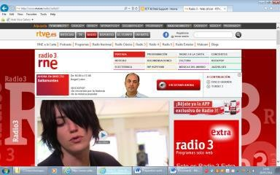
Listen to the music…
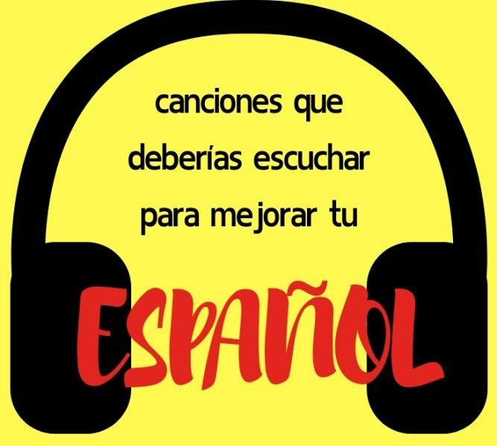

On Youtube or Spotify: start with Alvaro Soler, Shakira, DVicio, Pablo Alborán, Rosalía… Find your favourite songs and look for the lyrics!!

Grammar Practice

What should I know by now?
This is a common question asked by students about to start their A level. You should be able to:

TOPIC | CONTENT
Recognise and use a range of tenses with  regular verbs. | Regular –AR, -ER, -IR verbs: Tenses:  Present Preterite Imperfect  Near Future (ir + a + inf.) Future (eg. Será) Conditional (eg. sería)
Recognise and use a range of tenses with  irregular verbs. | Common irregular verbs: ser, estar, tener, hacer, ir  Tenses:  Present Preterite Imperfect  Near Future (ir + a + inf.)  Future (eg. será) Conditional (eg. sería)
Give opinions with reasons | - A range of opinion expressions  - Positive and negative reasons for opinions  - To be able to agree

Links to Grammar Practice Exercises
Cuaderno de gramática
The following websites are also very useful interactive sites for grammar and language based activities.
Languages on line: The Grammar Revision resources on www.languagesonline.org.uk are great as you can then select what tense you want to revise, read the explanations and complete the exercises. You can do these as often as you like and it gives you a percentage. Another useful tactic is to translate the examples and exercises into English to ensure you understand the meaning of each tense.

Lightbulb languages: at http://www.lightbulblanguages.co.uk/resources-sp-al.htm

Conjuguemos: a great website for practicing your verb conjugations. Find it here: https://conjuguemos.com/k

Duolingo, Memrise: By making use of the websites, Duolingo www.duolingo.com or Memrise www.memrise.com

Tasks
Complete the task log, or make your own one up. It will be great to see them in the front of your subject folders as a demonstration of the work you have undertaken to prepare for studying at College. They can also be a reminder of some great resources that you can go back to in the future to help you with revision and preparing for exams.

TASK 1
When you look at a website/ link on here, highlight it and note the date and what you thought about it. You can then put a couple of notes in your task log.

TASK 2
Read through the course overview so that you have an idea of what we will be studying. This will also help you with task 3 below.

TASK 3
Summarise, in Spanish, 2 articles (that were in Spanish!) that you have read from one of the websites/ papers above and say why they interested you. If you cannot print the article, make a note of the website. Try and make these related to one of the topics we will study (see course view)

TASK 4
Look out for any items in the English or Spanish media relating to topics we will study – as above so that you have points to make in a discussion and opinions to give.

TASK 5
Choose a Hispanic country and prepare a short presentation on an aspect of culture – this should last no longer than 5 minutes. You can create a PPT if you want, but try and use headings rather than too much prose on the slide. This will be good practice for your IRP (Independent Research Project).

TASK 6
Go onto www.languagesonline.org.uk . Complete 2 exercises a week. Each exercise takes less than 5 minutes. Note down the exercise you did and your score.

If you do all the above you'll be giving yourself a head start and helping yourself deal with the all- important transition from GCSE to A level.

¡Buena suerte!

Head Starts - Task Log

Date | Website / source | Comments

Year 1 and Year 2 Spanish Course Topics and Exam Format (AQA)
YEAR 1 - ASPECTS OF HISPANIC-SPEAKING SOCIETY: CURRENT TRENDS
Modern and traditional values (Los valores tradicionales y modernos)
- Los cambios en la familia
- Actitudes hacia el matrimonio/el divorcio
- La influencia de la Iglesia Católica
Cyberspace (El ciberespacio)
- La influencia de internet
- Los móviles inteligentes en nuestra sociedad
- Las redes sociales: beneficios y peligros
Equal rights (La igualdad de los sexos)
- La mujer en el mercado laboral
- El machismo y el feminismo
- Los derechos de los gays y las personas transgénero

YEAR 1 - ARTISTIC CULTURE IN THE HISPANIC WORLD
Modern day idols (La influencia de los ídolos)
- Cantantes y músicos
- Estrellas de televisión y cine
- Modelos
Spanish regional identity (La identidad regional en España)
- Tradiciones y costumbres
- La gastronomía
- Las lenguas
Cultural heritage (El patrimonio cultural)
- Sitios turísticos y civilizaciones prehispánicas: Machu Picchu, la Alhambra, etc.
- Arte y arquitectura
- El patrimonio musical y su diversidad

YEAR 2 - ASPECTS OF HISPANIC SOCIETY: SOCIAL ISSUES AND TRENDS
La inmigración
•
•
•
El racismo
•
•
•
Los beneficios y los aspectos negativos
La inmigración en el mundo hispánico Los indocumentados - problemas
Las actitudes racistas y xenófobas
Las medidas contra el racismo La legislación anti-racista
La convivencia y la integración
- La convivencia de culturas
- La educación
- Las religiones

Part 1: discussion of one sub-topic (5-6 min)
You will select one of two stimulus cards based on a sub-topic and prepare answers to the 3 printed questions. You must ask the examiner 2 questions. This will last five to six minutes.
Part 2: presentation and discussion of your individual research project (2 min + 9-10 min) You will present the findings on your research for up to 2 min and will take part in a conversation on that topic. This will last nine to ten minutes.

A range of listening questions based on the topics plus questions on a selection of written texts, covering both fiction and non-fiction material. Questions will target the main points, gist and detail and will include writing a summary of listening and reading material.

Two written essays based on each of the two works you have studied, a book and a film.
Year 1 and Year 2 Spanish Course Topics and Exam Format (AQA)

YEAR 2 - ASPECTS OF POLITICAL LIFE IN THE HISPANIC WORLD
Jóvenes de hoy, ciudadanos del mañana
- Los jóvenes y su actitud hacia la política : activismo o apatía
- El paro entre los jóvenes
- Su sociedad ideal
Monarquías y dictaduras
- La dictadura de Franco
- La evolución de la monarquía en España
- Dictadores latinoamericanos
Movimientos populares
- La efectividad de las manifestaciones y las huelgas
- El poder de los sindicatos
- Ejemplos de protestas sociales (eg. El 15-M, las madres de la Plaza de Mayo …)

Speaking Test : Oral | 21-23 minutes (including 5 minutes preparation time)
Weighting: | 30% of A level

Written Paper 1: Listening, Reading and Writing | 2 hours 30
Weighting: | 50% of A Level

Written Paper 2: Writing | 2 hours
Weighting: | 20% of A Level

Handy Vocab

Español | Inglés

